Erasmus Mobility for Teaching Assignment

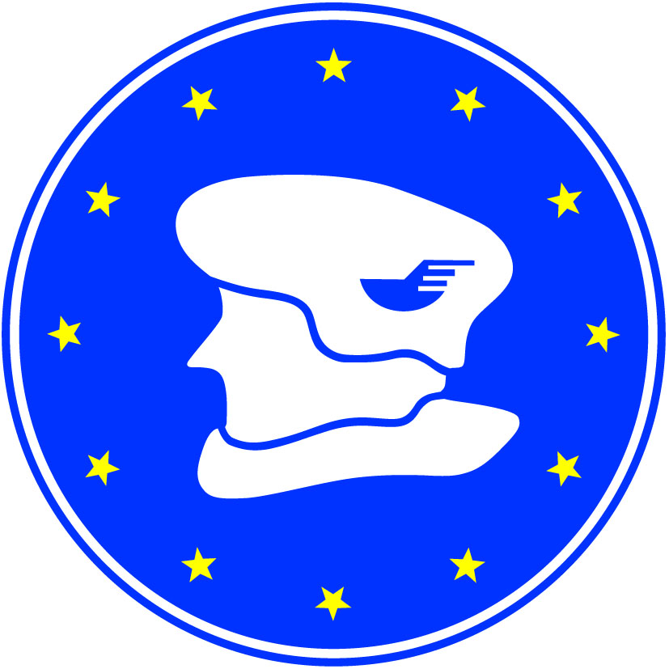
Application form

Name and Erasmus code of the home university
Faculty/Department
Name and Surname of participant (with titles)
Gender |  | F / M
e-mail
phone (with country code)
fax
Content of teaching programme
Level |  | Bachelor | Master |  | Doctorate | other , please specify ....
Arrival date |  |  |  | Departure date
Accommodation in the university hall of residence |  | Single room / double room
Accommodation in a hotel |  | 2 / 3 / 4 / 5 stars (list of the hotels will be offered later on)
Special needs

Place and date ................................................ Signature .......................................................

Approval of participation in the EIW (to be filled in by UTP IRO)

..........................................................................

Dear Partners,
On behalf of the University of Technology and Life Sciences I have the pleasure to announce the first Erasmus International Week for teachers from our partner universities, which will take place in Bydgoszcz (Poland) during the days 24th – 28th of October 2011.
This year our university celebrates 60th Anniversary and the International Week will be the one of the number of events organized at our institution during the whole year.
The purpose of the meeting is to welcome teachers from our partner institutions in order to acquaint each other and share experiences but also to enhance the process of “internationalization at home” thanks to lectures and presentations given by the hosted teachers to our students.
In the programme we can offer you different forms of teaching activities as well as cultural events according to Polish Presidency in EU.
We can welcome up to 50 persons. In order to participate in the EIW you have to fill in the attached application form.
The scanned version of the form have to be sent by e-mail to joanna.siolkowska@utp.edu.pl
or by fax +48 52 3749399, by 15th September 2011.
After that date the confirmation letters with detail agenda will be sent to all accepted participants.
The main communication language will be English.

