ANNEX 4
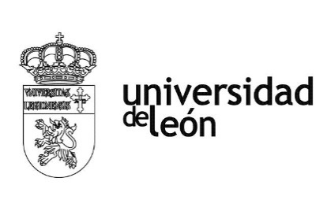

ATTENDANCE CERTIFICATE

To be signed by a responsible person at the International Office of the recipient University upon student departure and NEVER BEFORE the full completion of the study period. Invalid if amended or crossed.

IT IS HEREBY CERTIFIED THAT:

The STUDENT
, from the University of Leon

(Spain), has completed a full-time program in the study area of _______ at the (host institution) , city _, Country , during the period from:
/ /20___ to ___ / /20___ under the frame of the Bilateral Agreement linking both institutions.

Date: (must be equal or later than the end of academic period)

Name of signatory:

Position:

SIGNATURE: SEAL:

THE ORIGINAL VERSION OF THIS DOCUMENT IS NEEDED AT:

UNIVERSIDAD DE LEÓN
OFICINA DE RELACIONES INTERNACIONALES
Campus de Vegazana, Edificio de Servicios,
24007 LEÓN (SPAIN) Tfno.: +34 987 2916 56
Deadline: 1 month AFTER your final date in your certificate of attendance.

