4th INTERNATIONAL WEEK: DO WE KNOW SOMETHING ABOUT EUROPEAN COUNTRIES?
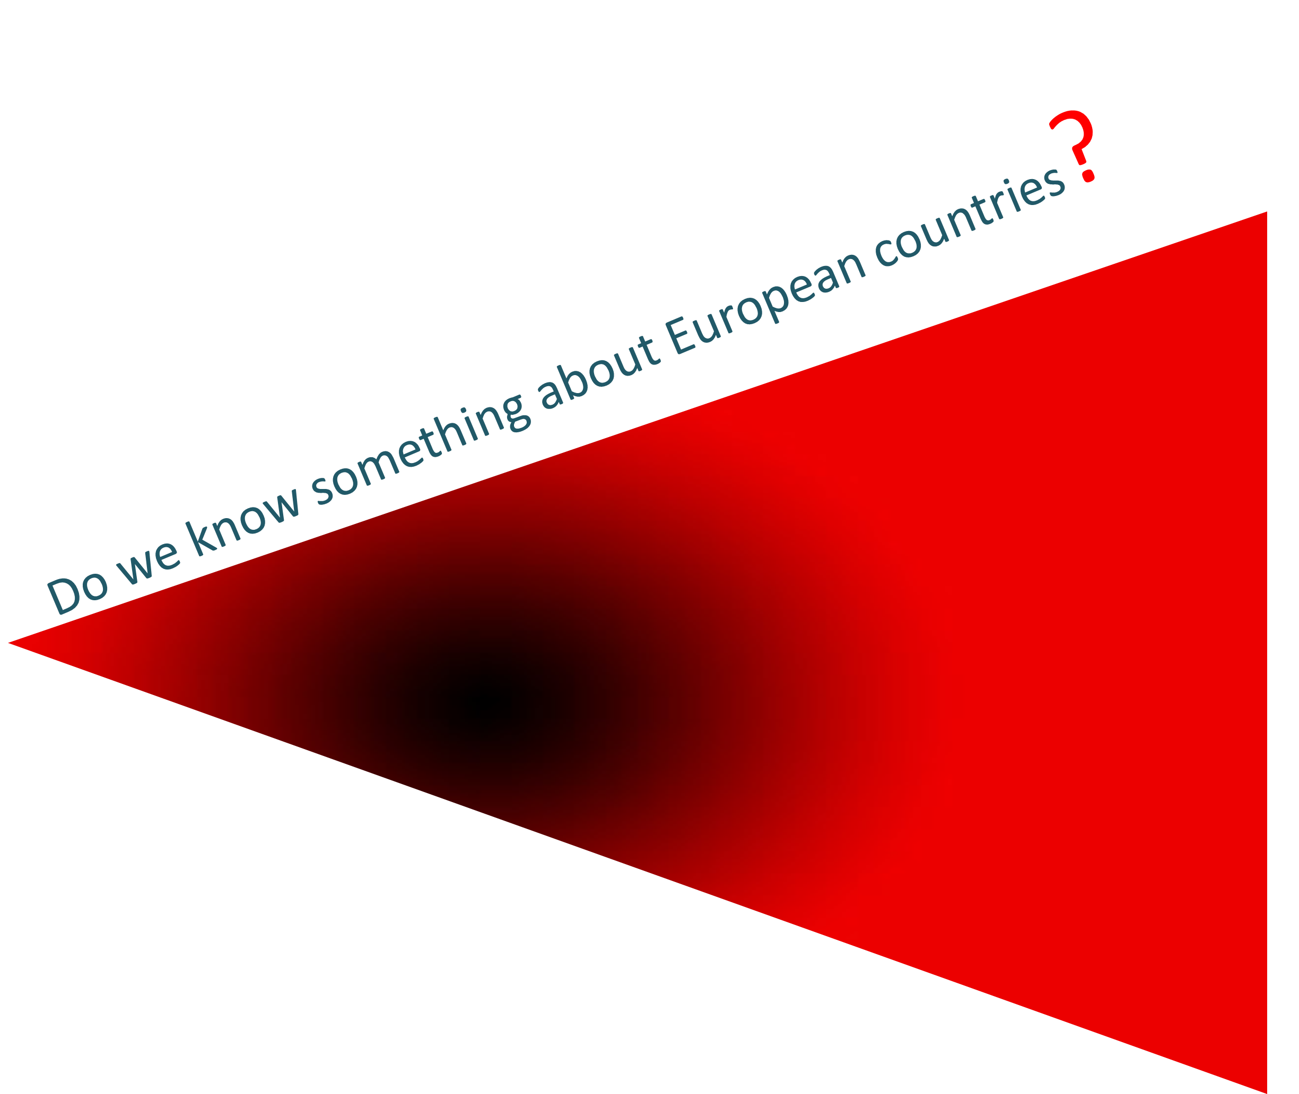

Facultad de Ciencias Económicas y Empresariales
Leon, 7th-11th May

BOLETÍN DE INSCRIPCIÓN

Nombre y Apellidos:

Tel. móvil: Tel. fijo: e.mail:

Domicilio: CP: Localidad: Provincia:

Titulación en la que está matriculado: Curso:

Facultad:

Participación en la 4th International Week (Se admite solicitud de asistencia para toda la Semana o para Seminario/s concretos):
Toda la semana día 7 día 8 día 9 día 10 día 11

Información y reserva (hasta el 5 de MAYO): Ángela González Díez, e-mail: feeint@unileon.es
Se entregará certificado de asistencia

Seminars
7  Monday | 08.30-09.00 | Opening
7  Monday | 09.00-11.00 | “The Economy of the Czech Republic from Different Perspectives”. Mr. PREMYSL PÁLKA, Vice-Dean for International Relations from the Faculty of Management and Economics. Tomas Bata University (Czech-Republic)
 | 11.30-13.30 | “POST ANALYTICS. Investigación avanzada de Mercados en León”. Mr. EMILIO DEL PRADO, Chief Operating Officer (Spain). Presentación de la empresa en español
 | 13.30-14.00 | “Presentation of the institution: Tomas Bata University in Zlin“. www.utb.cz. Mrs. MARTINA HUDEČKOVÁ, International Office. Tomas Bata Uni. (Czech-Republic)
 | 14.00-14.30 | “Presentation of the institution: HU University of Applied Sciences Utrecht”. www.international.hu.nl. Mrs. JELLY J. OFFEREINS, Director International Affairs HU Business School. HU University of Applied Sciences Utrecht (Netherlands)
8  Tuesday | 09.00-11.00 | “Oil and Stock markets”. Ms. DUC KHUONG NGUYEN, Ph.D., HDR, Professor of Finance. Chair of the Dept. of Finance and Information Systems, ISC Paris School of Management (France)
 | 11.30-13.30 | “Innovation and entrepreneurship in Portugal in the crisis context”. Mrs. PAULA ODETE, Department of Economics and Management, School of Technology and Management (ESTiG). Polytechnic Institute of Bragança (Portugal)
 | 13.30-14.00 | “Presentation of the institution: School of Technology and Management (ESTiG) Polytechnic Institute of Bragança”. www.estig.ipb.pt. Mrs. PAULA ODETE (Portugal)
 | 14.00-14.30 | “Presentation of the institution: ISC Paris School of Management”. http://nguyenduckhuong.com/. Ms. DUC KHUONG NGUYEN (France)
9  Wednesday | 09.00-11.00 | “Intercultural communication and negotiation styles”. Mrs. NÚRIA DOMÍNGUEZ RODRÍGUEZ, Communication and Information Sciences (CIW), Radboud University Nijmegen (Netherlands). Presentación en español
9  Wednesday | 11.30-13.30 | “The consumer behaviour in Finland”. Mrs. PIA VÄKIPARTA-LEHTONEN, Senior Lecturer, Marketing Business School. Helsinki Metropolia University of Applied Sciences (Finland)
 | 13.30-14.00 | “Presentation of the institution: Business School, Helsinki Metropolia University of Applied Sciences”. www.metropolia.fi. Mrs. PIA VÄKIPARTA-LEHTONEN (Finland)
 | 14.00-14.30 | “Presentation of the institution: Universidad Radboud de Nimega (RU)”. http://www.let.ru.nl/ciw-bc/. Mrs. NÚRIA DOMÍNGUEZ RODRÍGUEZ (Netherlands). Presentación en español
 | 15.30-17.00 | “Markclip: Promoción internacional de nuevos productos”. Mrs. COVADONGA BERTRÁN DEL RÍO, Account Manager Spanish-English. Markclip. Presentación en español
10  Thursday | 09.00-11.00 | "The CD/DVD covermount market in Belgium”. Mrs. LINDA COOPMAN, Lector marketing. De Hogeschool Brugge (Belgium)
10  Thursday | 11.30-13.30 | “Slovakia in 2012, the new beginning?”. Ms. MIROSLAV FECKO, Faculty of Public Administration in Kosice (Slovakia)
 | 13.30-14.00 | “Presentation of the institution: Kosice-Slovakia”. Ms. MIROSLAV FECKO
 | 14.00-14.30 | “Presentation of the institution: De Hogeschool West-Vlaanderen”. www.howest.be. Mrs. SYLVIE DESMET, De Hogeschool Brugge (Belgium)
 | 18.30-20.00 | “Mercados digitales: nuevos retos de investigación”. Mrs. LAURA LUDEÑA MUÑOZ, Directora de Investigación de Mercados, Google España y Portugal. Presentación en español
11  Friday | 09.00-11.00 | "Business model of filmed entertainment". Mrs. LINDA COOPMAN (Belgium)
11  Friday | 11.30-13.30 | "The Higher Education System in Switzerland". Mr. SIGMAR WILLI, Professor, FHS St. Gallen. University of Applied, Sciences St.Gallen (Switzerland)
 | 13.30-14.00 | “Presentation of the institution: FHS St.Gallen - University of Applied Sciences St.Gallen”. http://www.fhsg.ch/en/international. Mr. SIGMAR WILLI (Switzerland)

